**Design**

**Doping Profile**

The effect of substrate resistivity shows in the solar cell as variations in the open circuit voltage and in the short circuit voltage. In the simulations performed in laboratory 1, it can be observed that as the substrate resistivity changed, the short circuit current decreased and the open circuit voltage increased. The maximum power output, fill factor and efficiency of the solar cell increased as well. The results for this simulation are summarized in Table 1 below. The solar cell that was fabricated for the project has a medium resistivity of 7.68 Ω.cm.

Table 1: Effect of Substrate Resistivity

|  |  |  |  |  |  |  |
| --- | --- | --- | --- | --- | --- | --- |
| **ΡB (Ωcm)** | **NB** | **Jsc (mAcm-2)** | **Voc (mV)** | **FF** | **Pmax (mWcm-2)** | **ɳ (%)** |
| 10 | 1.368e15 | 0.03617 | 0.55 | 0.797725 | 0.015871 | 15.871 |
| 1 | 1.513e16 | 0.035607 | 0.61 | 0.8280 | 0.017985 | 17.985 |
| 0.1 | 2.341e17 | 0.03449 | 0.65 | 0.8382 | 0.01879 | 18.79 |

Sheet resistance is important as it can be measured directly, compared to the junction depth or surface doping concentration and this can help us characterize the emitter. The sheet resistance is measured using a four-point probe. It is measured on the top surface n-type layer. In the simulations ran for this project, it can be observed that as the sheet resistance increases, the fill factor and the overall solar cell efficiency gets lower. This is due to the effect that sheet resistance has on the diffusion length. The effects are summarized on Table 2 below. The sheet resistance for the solar cell produced and tested during this project is 84.4 Ω/□.

Table 2: Effect of Sheet Resistance

|  |  |  |  |  |
| --- | --- | --- | --- | --- |
| **NDO (cm-3)** | **Depth factor (μm)** | **Rs (Ω/sqr)** | **Xj (μm)** | **Jsc (mAcm-2)** |
| 3e20 | 0.3 | 16.82 | 0.8599 | 0.03267 |
| 3e20 | 0.2 | 25.23 | 0.5733 | 0.03435 |
| 3e20 | 0.1 | 50.45 | 0.2866 | 0.03561 |
| 3e20 | 0.05 | 100.9 | 0.1433 | 0.0359 |

**Front Contact Grid**

The contact grid optimization process included calculating all the power losses present on the solar cells. These are the fractional power loss due to current flow through the emitter layer resistance, the fractional power loss due to shadowing by the grid fingers, the fractional power loss due to current flow through the grid finger resistance, the fractional power loss due to shadowing by the busbar and the fractional power loss due to current flow through the busbar resistance. The equations to calculate the different fractional power losses are as follow:



The fractional power loss due to current flow through the emitter layer resistance:

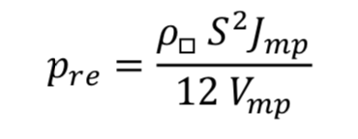 (Equation 14)

The fractional power loss due to shadowing by the grid fingers:

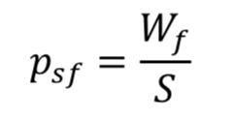(15)

The fractional power loss due to current flow through the grid finger resistance:

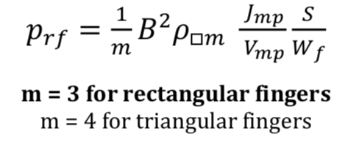(Equation 16)

On this project, since the fingers are rectangular, m = 3.

The fractional power loss due to shadowing by the busbar:

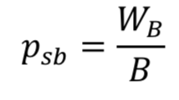 (Equation 17)

The fractional power loss due to current through the busbar resistance:

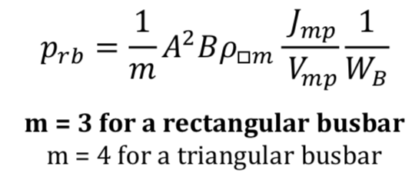 (Equation 18)

On this project, since the busbar is rectangular, m = 3.

For the optimization of the contact grid, the group was assigned to work with a sheet resistance of 12 Ω/□. The multiple fractional power losses were used to optimize the different distances within the solar cell, such as: the optimal separation between fingers, the width of the busbar, the width of the fingers, the width of the cell, the length of the fingers and the number of fingers. The results are summarized below on Table 3.

Table 3: Cell Distances (where

|  |  |
| --- | --- |
| Separation between fingers, S |  |
| Width of the bus, Wb |  |
| Width of the fingers, Wf |  |
| Width of the cell, A | 0.0051 |
| Length of the fingers, B |  |
| Number of Fingers | 6 |

The design of the solar cell can be observed in Figure 11.

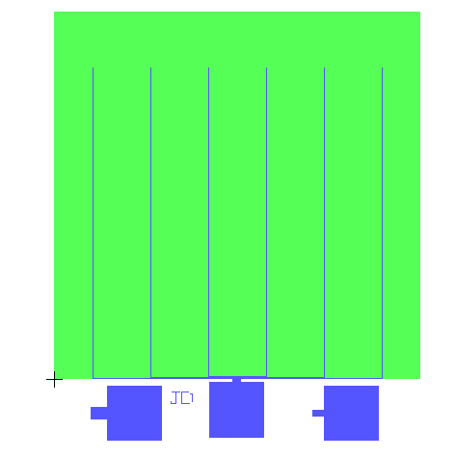

Figure 1: Group's Solar Cell

The values were determined using the MATLAB code below:

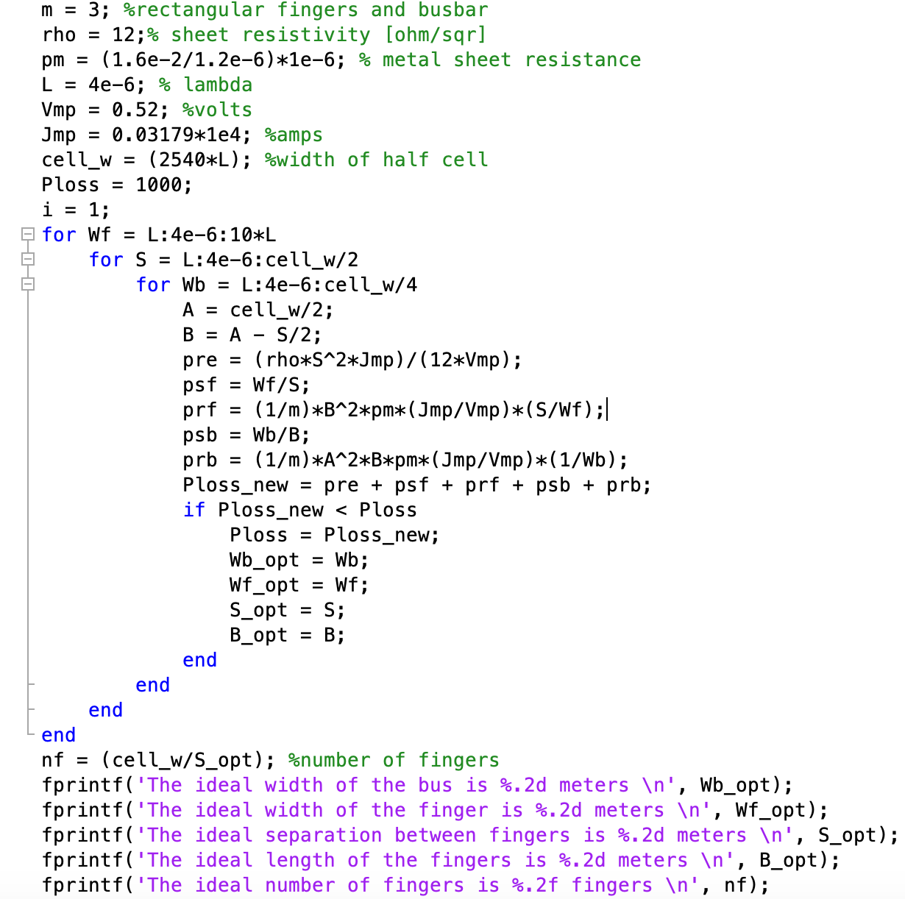

Figure 2: MATLAB Code for Optimization of Contact Grid

**Optical Design**

The effective refractive index of a cell with a single layer of AR coating is calculated using equation 19. Subbing the values of the film and substrate reflective index, equation 19 yields a neff = 0.3833.

 (19)

It is not possible to get a film that the exact appropriate refractive index. In the case of our project, the layer used is Silicon Nitride (Si3N4) and it has a refractive index of approximately 1.95. The optimum AR thickness was calculated to be 64.87 nanometers, using equation 20 with a wavelength of 506nm. The result determined was not correct, due to unknown reasons.

 (20)

**Testing and Results**

The group’s solar cell was tested, to find the cell’s illuminated I-V characteristics. The graph in Figure 12 shows the measurements of the cell’s short circuit current, open circuit voltage, maximum power voltage, and maximum power current. The cell, which results are shown in Figure 12, has AR coating. The green lines are for the Vmp and Isc. The Voc measured was 0.53V, the Vmp measured was 0.41V, the Isc measured was 18.17mA and the Imp measured was 15.07mA. The current density of the cell under illuminated conditions was calculated to be 17.602 mA/cm2, the fill factor was calculated to be 64.16% and the efficiency was calculated to be 5.99%.

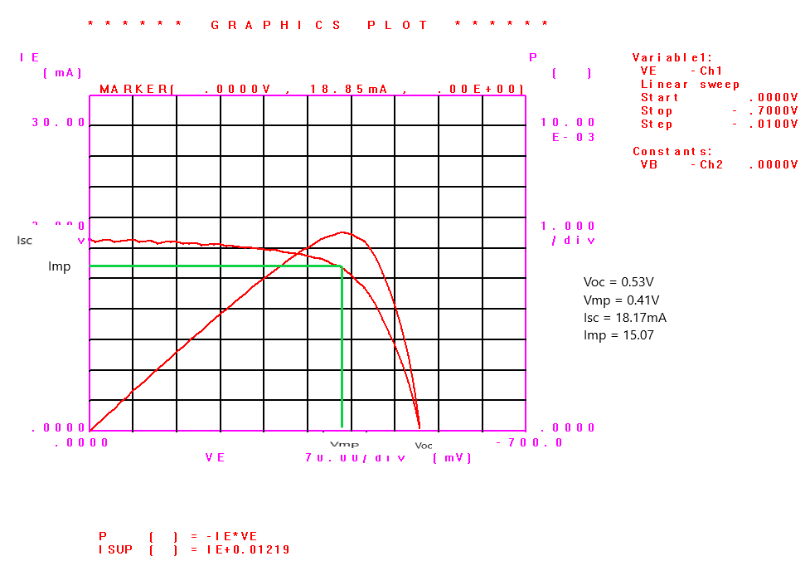

Figure 3: Illuminated Solar Cell I-V Characteristics with AR Coating

The same measurements were performed for the solar cell with no ARC coating. The predictions that were performed for the cell in Lab 3 were approximately close, except for the prediction for the current density that was much higher than the value obtained from the cell. The coating of the cell gives it an amethyst hue. The I-V characteristics for the solar cell can be observed in Figure 13. The green lines are for the Vmp and Isc. The Voc measured was 0.52V, the Vmp measured was 0.42V, the Isc measured was 8.123mA and the Imp measured was 7.202mA. The current density of the cell under illuminated conditions was calculated to be 7.8692 mA/cm2, the fill factor was calculated to be 71.61% and the efficiency was calculated to be 2.93%. It can be observed that there is an improvement of 55.3% in the cell’s current density when ARC is used.

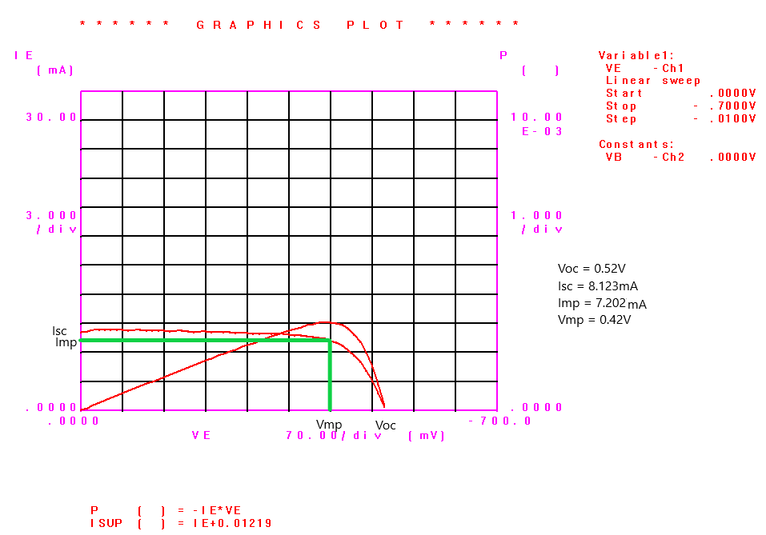

Figure 4: Illuminated Solar Cell I-V Characteristics without AR Coating

The superposition principle states that the current that flows through an illuminated solar cell at a bias voltage is given by adding the dark current and the short circuit photocurrent. An experiment was performed with the group’s cell to verify that the superposition was indeed correct. In Figure 14, it can be observed that both the dark current and the short circuit photocurrent are graphed. The currents were combined, and it yield the value expected of IL.

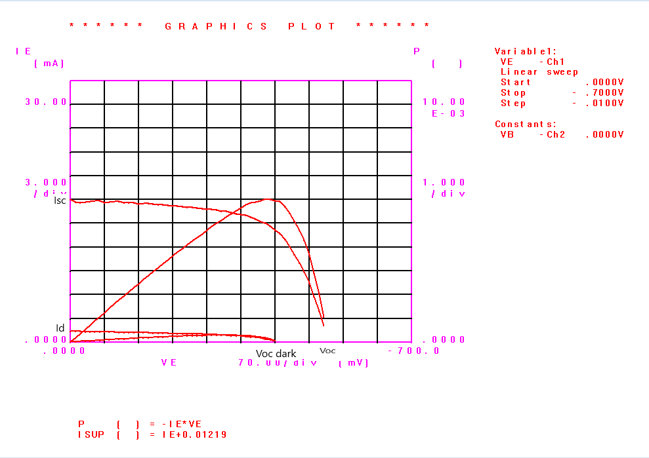

Figure 5: The Superposition Principle

The solar cell was tested at different temperatures to observe what happens to its open circuit voltage and to its short circuit current. The two temperatures at which the cell was tested were 20˚C and 40˚C. It can be observed in Figure 15 that the Isc of the cell remains constant, but the Voc of the cell at 40˚C is lower than at 20˚C.

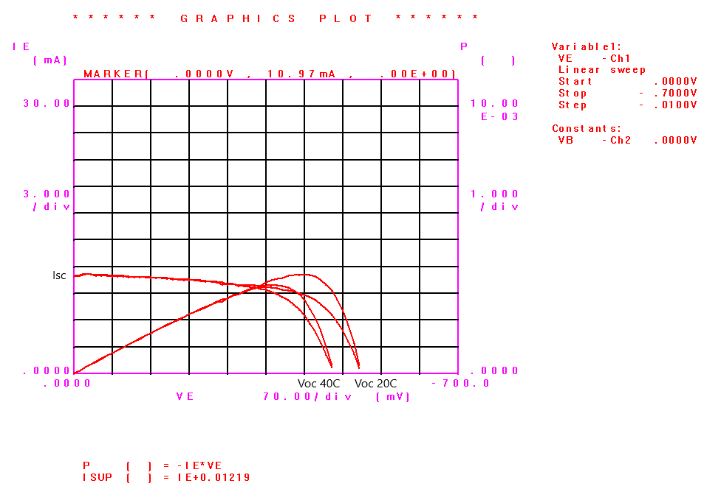

Figure 6: Temperature Effects

The solar cell was exposed to light that went through two different filters. The purpose of this test was to observe the effect of specific wavelengths on the solar cell. The light was passed through both a yellow and a red filter, and the effects were documented and can be observed on Figure 16. It can be seen that both yield a similar I-V characteristic, this is due to the fact that the wavelengths for red and yellow are very similar. The light that went through the yellow filter yielded a higher maximum power point.

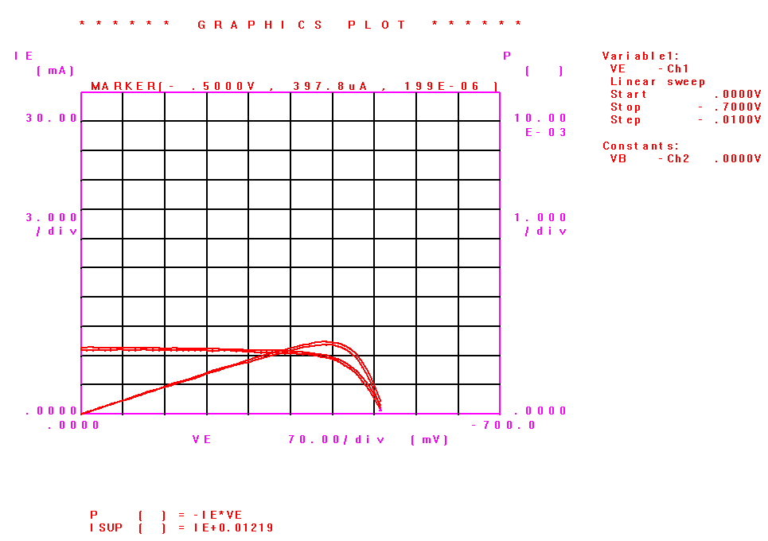

Figure 7: Effect of Filters on Solar Cell